 | QA/QC PROCEDURES MANUAL | Doc. Code : PM-OPN-2-
 | QA/QC PROCEDURES MANUAL | Rev. No. : 0
 | QA/QC PROCEDURES MANUAL | Eff. Date : Sept. 16, 2026
 | QA/QC PROCEDURES MANUAL | Pages : 1-6

Boysen Plexibond B‑7760 — Cementitious Waterproofing: Step‑by‑Step Procedure
This document provides a complete, actionable application procedure for BOYSEN Plexibond B‑7760 cementitious waterproofing system. It covers scope and uses, materials and tools, surface preparation, mixing, application (vertical and horizontal), reinforcement, curing and protection, safety, quality checks, and recommended top‑coat schedule. Follow manufacturer instructions and local safety regulations.

1. Scope & Typical Uses
BOYSEN Plexibond B‑7760 is a cementitious polymer waterproofing system intended for positive‑side waterproofing of concrete surfaces such as roof decks, parapets, ledges, canopies, firewalls, and similar substrates. It is compatible with common top coats including BOYSEN Permacoat Latex, Acrytex, Acqua Epoxy, and Epoxy Enamel.

2. Materials, Tools, and PPE
Item | Specification / Typical Quantity
BOYSEN Plexibond B‑7760 (liquid) | 4 L per 6.5–7.5 kg Portland cement (ratio: 1 part liquid : ~6.5–7.5 parts cement by weight)
Portland cement (Type I/II) | 6.5–7.5 kg per 4 L Plexibond
Clean water | For dampening substrate and tool cleaning
Mixing tools | Large clean bucket, low‑speed drill with mixing paddle, shovel
Application tools | Textured roller, natural‑bristle brush, plastic trowel, mortar gun (optional)
Reinforcement | Fiberglass mesh/matting for joints, cracks, and corners
Protection materials | Plastic sheeting for curing protection, masking tape
Safety PPE | Gloves, goggles, dust mask/respirator, waterproof boots, hard hat where required

3. Surface Preparation (Step 1)
- Remove all loose or delaminated concrete, paint, coatings, oil, grease, dust, and other contaminants. Use scraper, wire brush, pressured water cleaning, or mechanical methods as required.
- Repair spalls, large defects, and deteriorated concrete. Use suitable repair mortar or patching compound and allow the repair to cure according to its manufacturer’s directions.
- For new concrete, allow a minimum curing period of 14–28 days before applying Plexibond to ensure moisture and strength stabilization.
- Dampen the substrate with clean water until it is uniformly moist but not ponding. The surface must be moist to avoid rapid absorption of water from the slurry which can cause shrinkage cracks and poor adhesion.
- Remove any remaining alkali bloom or salts by mechanical means; surface must be free of loose particles. Previously painted or sealed areas must be stripped to expose bare substrate for proper bonding.

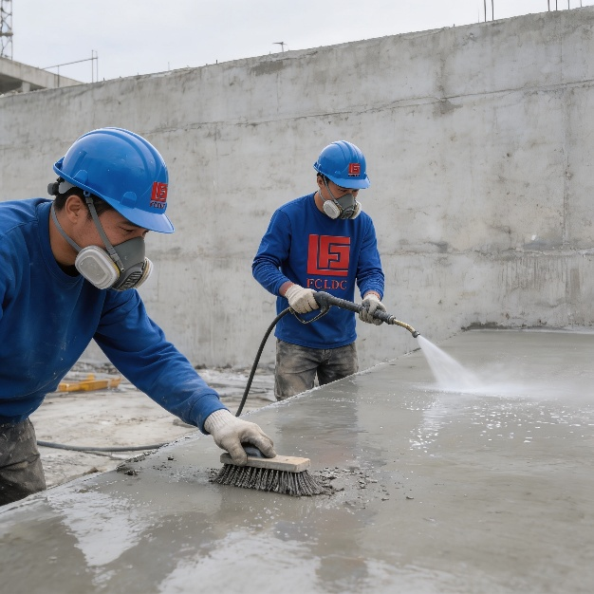
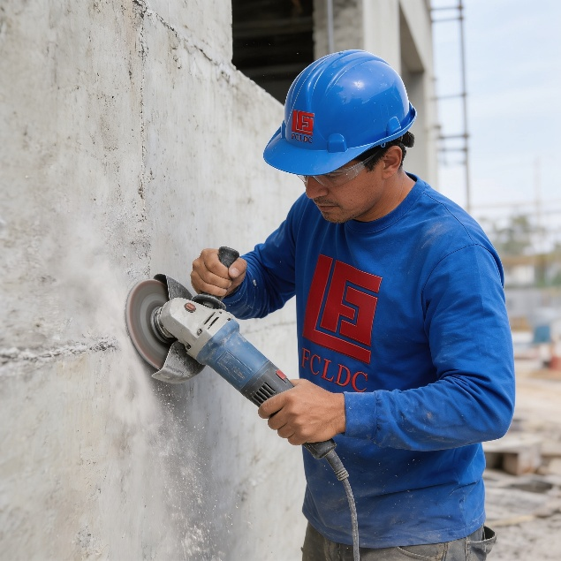
4. Material Preparation & Mixing (Step 2)
Accurate mixing is critical to performance. Follow these steps for consistent, lump‑free slurry:
- Measure components: For each 4 L container of Plexibond liquid, weigh 6.5–7.5 kg of Portland cement. Maintain consistent proportions for all batches.
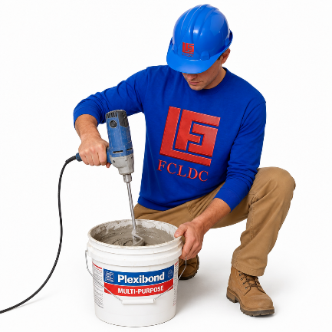
- Place the measured cement into a clean mixing container.
- Slowly add the 4 L Plexibond liquid into the cement while stirring continuously.
- Mix using a low‑speed drill with paddle or by hand with a shovel until a uniform, lump‑free paste is achieved. The desired consistency is a smooth, spreadable slurry without dry pockets.
- Optional: Pass the mixed slurry through a fine strainer to remove any lumps before placing.
- Workability and pot life: The mixed slurry should be placed within about 30 minutes to maintain workability. Discard any material that has exceeded its pot life (approximately 2 hours).
- Do not alter the specified liquid:cement ratio significantly. Small adjustments within the recommended range can be used to fine‑tune workability; avoid adding extra water.

5. Application Overview (Steps 3–5)
Application differs for vertical and horizontal surfaces. Ensure ambient conditions are suitable (preferably 20–30 °C and relative humidity 30–70 %). Avoid application during rain, high wind, or direct hot sun that causes rapid drying.

5.1 Vertical Surfaces (Firewalls, Parapet Faces)
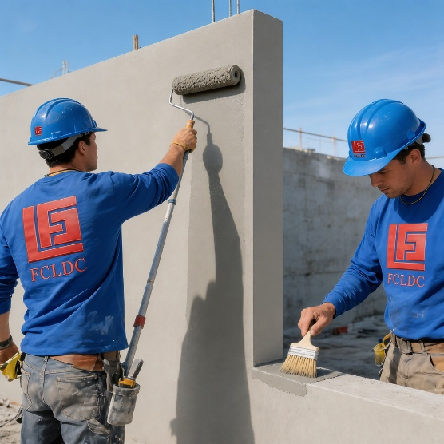
- Select finish: For a textured finish use a textured roller; for a smoother finish use a natural‑bristle brush and trowel where appropriate.
- Apply first coat: Using a brush or roller, apply the mixed slurry evenly at a coverage of approximately 5–6 m² per 4 L container (this corresponds to an approximate wet film thickness around 11 mils per coat). Maintain a wet edge and avoid dry spots.
- Recoat interval: Allow the first coat to set until tacky/dry to the touch—typically 1–2 hours depending on conditions—before applying the second coat. Do not exceed the recommended recoat window (ideally recoat within 2 hours) to ensure intercoat adhesion.
- Apply second coat: Apply a second full coat using the same method. Two coats are typically sufficient for vertical applications.
- Drying: Allow the final coat to cure at least 24 hours before top coating with paint or exposing to light traffic. Full cure for heavy traffic or harsh weather exposure is longer (see Section 7).

5.2 Horizontal Surfaces (Roof Decks, Ledges, Balconies)
Horizontal decks demand greater build and reinforcement across joints and movement areas. Follow these steps:
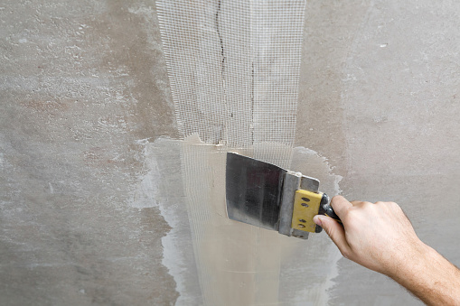
- Apply multiple coats: Apply 3–5 coats of the Plexibond slurry to build the required thickness and ensure full coverage. Use a brush or textured roller for distribution and a trowel for smoothing as required.
- Embed reinforcement at vulnerable points: At expansion joints, pipe penetrations, internal corners, and active cracks, embed a strip of fiberglass mesh matting while the second coat is still wet. Position the matting so it fully conforms to the surface and will be fully saturated and covered by subsequent coats.
- Ensure full encapsulation: The matting must be completely covered and integrated by the following coat(s) so there are no exposed fibers at the surface.
- Finish coats: After embedding matting and completing remaining coats, finish the surface to the desired texture (roller for orange‑peel, trowel for smoother finish). Maintain consistent coverage rate per coat to achieve uniform thickness across the deck.
- Crack repair: For filling non‑working cracks, prepare a trowellable repair mortar by combining 3 parts fine sand with 1 part cement (by volume) and enough Plexibond to obtain a trowelable consistency. Press into the crack, level, then continue with the coating sequence.

5.3 Joint and Detail Treatment
- Clean joints and remove loose material. Where movement is expected, install a suitable flexible joint material before coating or use flexible detail treatment recommended by the waterproofing specification.
- At parapet‑to‑deck intersections and vertical transitions, extend Plexibond at least 100 mm up the vertical face and integrate fiberglass matting across the transition for reinforcement.
- At drains and penetrations, form a neat fillet using trowellable Plexibond mortar and reinforce with mesh where needed to prevent future ponding and ensure positive drainage slope.

6. Curing, Protection, and Recoat Timing
Proper curing and protection preserve membrane integrity and reduce cracking risk.
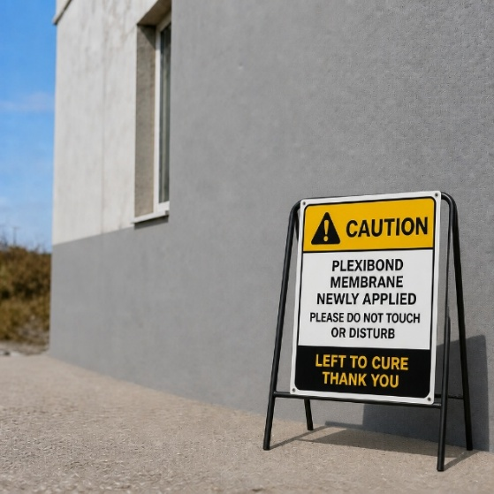
- Initial set: Product typically becomes touch‑dry within about 2 hours at 25 °C and 50 % RH; conditions affect this significantly.
- Between coats: Keep the surface shaded and protected from direct sun, wind, and rain between coats. Aim to recoat within 1–2 hours as recommended—do not allow excessive drying between coats that will compromise intercoat adhesion.
- Post‑application cure: Protect the finished membrane from rain and mechanical damage for a minimum of 24 hours. For heavy traffic or exposure to severe weather, allow at least 7 days for more complete cure before subjecting the membrane to stress.
- If rain is expected during initial cure, protect the coated area with plastic sheeting and ensure good ventilation beneath the sheeting to avoid trapping moisture.

7. Workflow chart
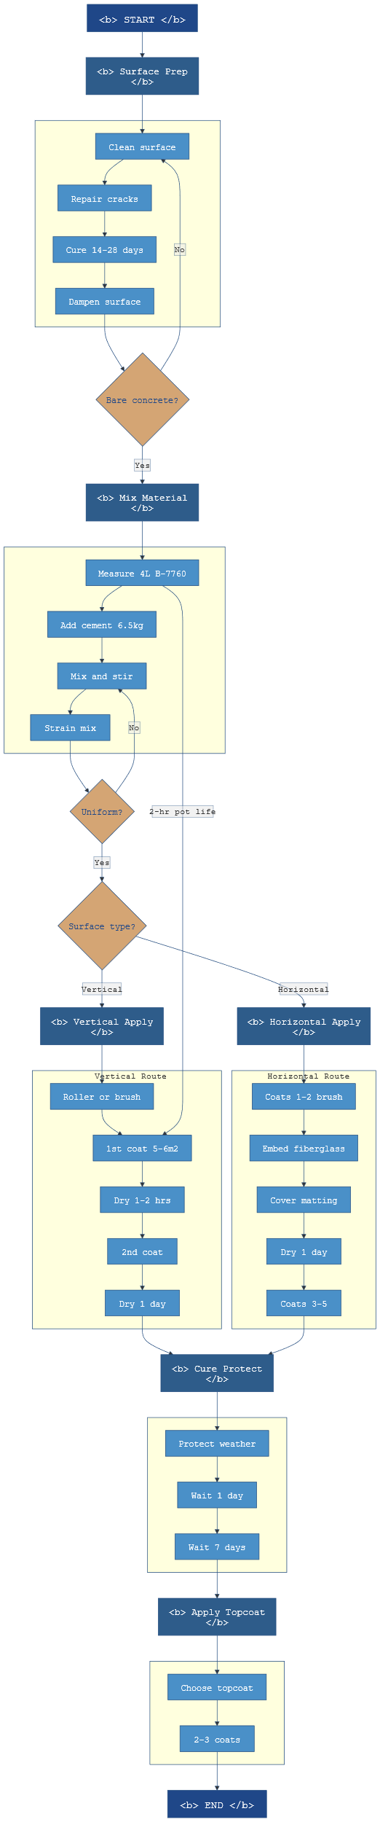
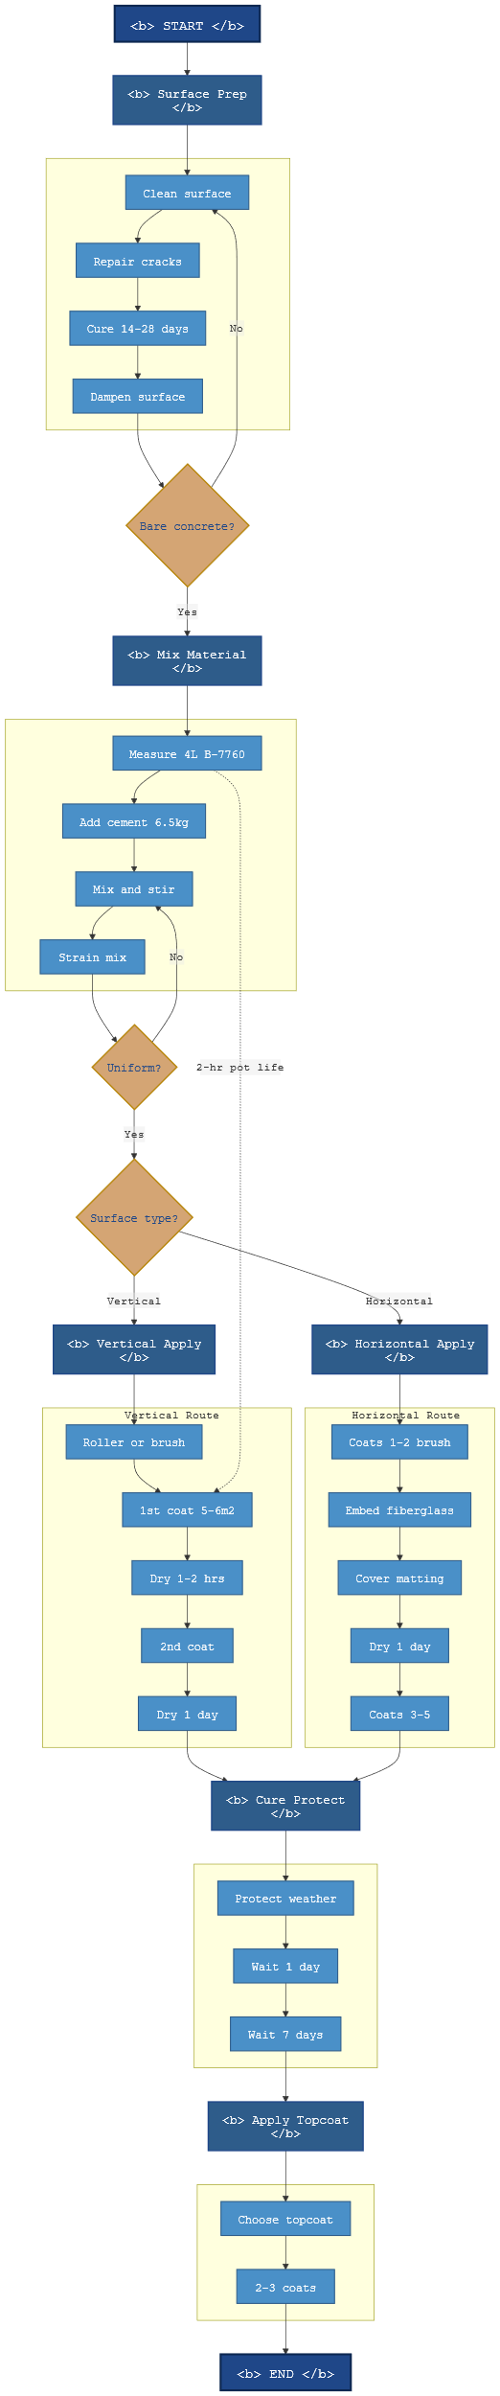

8. Safety, Cleanup, and Storage
- Use appropriate PPE (gloves, goggles, dust mask/respirator) during mixing and application. Ensure adequate ventilation when working in enclosed spaces.
- Avoid direct skin contact with the fresh slurry. If contact occurs, wash thoroughly with water.
- Clean tools and equipment with water immediately after use. Hardened material must be removed mechanically.
- Spill response: Contain spills, absorb with inert material, and dispose of per local regulations.
- Store liquid polymer containers in a cool, dry place away from direct sunlight. Keep cement stores dry and off the ground.

9. Recommended Top‑Coat Schedule
Allow Plexibond to dry at least 24 hours before applying any top coat. For typical top coats (example: BOYSEN Permacoat Latex):
- Confirm membrane is dry to the touch and free of contamination.
- Apply primer or sealer if recommended by the top‑coat manufacturer.
- Apply 2–3 coats of top coat per the top‑coat technical data sheet, respecting recommended drying times between coats.
- Final inspection: Verify adhesion, continuity, and uniform coverage before handing over the surface.

10. Quality Control Checklist
- Surface is clean, sound, and appropriately dampened.
- Correct mixing proportion used: 4 L Plexibond : 6.5–7.5 kg cement.
- Slurry mixed to a lump‑free consistency and strained if necessary.
- Coats built to specified number and coverage; matting properly embedded at joints and transitions.
- Recoat intervals observed and protective measures instituted during cure.
- Safety procedures followed and tools cleaned after use.

11. Typical Technical Notes (Reference values)
Property | Typical Value / Note
VOC | ≤ 17.8 g/L
Density | ≈ 1.01 kg/L (±0.05)
Touch dry time | ≈ 2 hours at 25 °C / 50 % RH
Typical coverage | ≈ 5–6 m² per 4 L per coat (estimate depending on substrate profile)
Recoat window | Typically within 2 hours; allow 24 hours before painting

12. Step‑by‑Step Summary (Quick Reference)
- Surface preparation: clean, repair, and dampen substrate.
- Prepare mix: 4 L Plexibond liquid + 6.5–7.5 kg cement; mix to lump‑free slurry.
- Apply coats: vertical — usually 2 coats; horizontal — 3–5 coats depending on build required; maintain coverage ~5–6 m² per 4 L per coat.
- Embed fiberglass matting at joints and vulnerable details while second coat is wet; fully cover with subsequent coats.
- Cure and protect: allow at least 24 hours before painting; minimum 7 days before heavy traffic or full exposure.

13. Notes and Manufacturer Reference
This procedure is based on BOYSEN Plexibond B‑7760 product guidance and standard cementitious waterproofing practices. Always consult the latest BOYSEN technical data sheet and safety data sheet for product‑specific limitations, local environmental considerations, and the most current recommendations. Adapt the procedure for ambient conditions, substrate type, and project specification.

14. APPENDICES

Service Agreement

PM-OPN-02-16 Painting Works Checklist form

Billing form

